City of Mountain View
Consolidated Annual Performance Evaluation Report (CAPER)
FY 2022-2023
September 8, 2023

Public Noticing of 2022-23 CAPER
Newspaper Ad Published in Palo Alto Daily Post and Mountain View Voice on September 8, 2023
CAPER posted on the City’s website on September 8, 2023
Public Comment Period: September 8, 2023 to September 24, 2023

Contact Information:
Harsha Ramchandani
City of Mountain View
Housing and Neighborhood Services Division
500 Castro Street
Mountain View, CA 94039
Email: neighborhoods@mountainview.gov
Phone: 650-903-6004
eFax: 650-963-3081
www.mountainview.gov\housing

(THIS PAGE INTENTIONALLY LEFT BLANK)

CR-05 - Goals and Outcomes
Progress the jurisdiction has made in carrying out its strategic plan and its action plan. 91.520(a)
This could be an overview that includes major initiatives and highlights that were proposed and executed throughout the program year.

For Program Year 2022, the City of Mountain View received $624,777 in CDBG entitlement funds. In addition to the CDBG entitlement funds, for the CDBG program, the City received $251,744 in Program Income and had $248,112 in Prior Year CDBG funds for a total of $1,124,633 in CDBG funds. The City also received $297,598 in HOME entitlement funds. For the HOME program, the City received $665,834 in Program Income and $428,677 in Prior Year Resources for a total of $1,392,109 in HOME funds. Due to greater Program Income than expected for both CDBG and HOME, these totals exceeded the estimate given in the Annual Action Plan.
The City’s major accomplishments for Program Year 2022 are as follows:
- 3,790 low-income individuals and families were provided case management services which includes advocacy, enrollment in benefits and housing through the Community Services Agency Homeless Prevention program. This program supports both, housed and un-housed community members
- 38 seniors were provided case management to help obtain housing, healthcare, food, and transportation with the goal of helping them live independently through the Community Services Agency Senior Case management program
- 44 persons with disabilities received services to aid them in transitioning from homelessness, unstable, or temporary housing to permanent, affordable, and accessible housing through Silicon Valley Independent Learning Center (SVILC)
- 38 visually impaired persons were provided case management and support services to live independently
- 47 seniors received legal assistance from Legal Services for Seniors
68 LMI unhoused youth and their families were served through Bill Wilson Center’s Family Advocacy Services program. This unique multi-generational program is school-based and aims to decrease and prevent homelessness and poverty through prevention and intervention resources
Comparison of the proposed versus actual outcomes for each outcome measure submitted with the consolidated plan and explain, if applicable, why progress was not made toward meeting goals and objectives. 91.520(g)
Categories, priority levels, funding sources and amounts, outcomes/objectives, goal outcome indicators, units of measure, targets, actual outcomes/outputs, and percentage completed for each of the grantee’s program year goals.

Goal | Category | Source / Amount | Indicator | Unit of Measure | Expected – Strategic Plan | Actual – Strategic Plan | Percent Complete | Expected – Program Year | Actual – Program Year | Percent Complete
Address and Promote Fair Housing | Affordable Housing  Homeless  Non-Homeless Special Needs | CDBG: $ | Public service activities for Low/Moderate Income Housing Benefit | Households Assisted | 150 | 0 | 0.00%
Enhance Physical Infrastructure | Non-Housing Community Development | CDBG: $ | Public Facility or Infrastructure Activities other than Low/Moderate Income Housing Benefit | Persons Assisted | 1300 | 1490 | 114.62%
Increase Affordable Housing | Affordable Housing | CDBG: $ / HOME: $ | Rental units constructed | Household Housing Unit | 150 | 50 | 33.33%
Increase Affordable Housing | Affordable Housing | CDBG: $ / HOME: $ | Rental units rehabilitated | Household Housing Unit | 200 | 0 | 0.00%
Increase Affordable Housing | Affordable Housing | CDBG: $ / HOME: $ | Homeowner Housing Rehabilitated | Household Housing Unit | 50 | 0 | 0.00%
Planning and Administration | Program administration funds | CDBG: $ / HOME: $ | Other | Other | 1 | 1 | 100.00%
Promote Economic Resiliency | Economic Development | CDBG: $ | Jobs created/retained | Jobs | 40 | 0 | 0.00%
Respond to Homelessness | Homeless | CDBG: $ / HOME: $ | Public service activities other than Low/Moderate Income Housing Benefit | Persons Assisted | 15000 | 10882 | 72.55% | 1416 | 3794 | 267.94%
Respond to Homelessness | Homeless | CDBG: $ / HOME: $ | Tenant-based rental assistance / Rapid Rehousing | Households Assisted | 1200 | 0 | 0.00%
Respond to Homelessness | Homeless | CDBG: $ / HOME: $ | Homeless Person Overnight Shelter | Persons Assisted | 0 | 0 |  | 0 | 0
Respond to Homelessness | Homeless | CDBG: $ / HOME: $ | Overnight/Emergency Shelter/Transitional Housing Beds added | Beds | 7 | 0 | 0.00% | 0 | 0
Support Social Services | Affordable Housing  Homeless  Non-Homeless Special Needs  Non-Housing Community Development | CDBG: $ | Public service activities other than Low/Moderate Income Housing Benefit | Persons Assisted | 2000 | 1202 | 60.10% | 379 | 346 | 91.29%
Table 1 - Accomplishments – Program Year & Strategic Plan to Date

Assess how the jurisdiction’s use of funds, particularly CDBG, addresses the priorities and specific objectives identified in the plan, giving special attention to the highest priority activities identified.
As indicated in the 2020-25 Consolidated Plan and Program Year 2020 Action Plan, the highest priorities for the City are: (1) increase affordable housing; (2) respond to homelessness; (3) support social services: (4) strengthen neighborhoods; (5) promote fair housing; and (6) promote economic resiliency. The City is making steady progress toward meeting these goals.

CR-10 - Racial and Ethnic composition of families assisted
Describe the families assisted (including the racial and ethnic status of families assisted). 91.520(a)

 | CDBG | HOME
White | 3,440 | 0
Black or African American | 93 | 0
Asian | 499 | 0
American Indian or American Native | 14 | 0
Native Hawaiian or Other Pacific Islander | 28 | 0

Total | 4,074 | 0

Hispanic | 1,731 | 0
Not Hispanic | 2,343 | 0

Table 2 – Table of assistance to racial and ethnic populations by source of funds

Narrative
In FY 2022-23, the City’s CDBG funded programs and services served 4,140 individuals. Of the beneficiaries served 3,440 were White; 93 were Black or African American; 499 Asian; 14 American Indian/Alaskan Native; and 28 Native Hawaiian/Pacific Islander. Of the total beneficiaries served during the fiscal year, 1,746 identified themselves as Hispanic, accounting for approximately 42 percent (42%) of the total individuals served.
The attached table reflects all the racial categories served by the City’s CDBG funded projects and programs using HUD-required reporting categories. Below is a summary of the additional racial categories that were served in Program Year 2022.
- 9 American Indian/Alaskan Native and White (less than 1%)
- 16 Asian and White (less than 1%)
- 8 Black/African American and White (less than 1%)
- 2 American Indian or American Native and Black or African American (less than 1%)
- 31 Other/Multi-Racial (less than 1%)
The City of Mountain View, through all the CDBG funded programs, served a total of 44 people living with a disability during the fiscal year. Additionally, 342 female heads of households and 804 elderly seniors were provided services. The City’s public service providers included: Bill Wilson Center, Catholic Charities, Community Services Agency, Next Door Solutions to Domestic Violence, Senior Adults Legal Assistance, Silicon Valley Independent Learning Center, Day Worker Center, LifeMoves, and Vista Center for the Blind and Visually Impaired.

CR-15 - Resources and Investments 91.520(a)
Identify the resources made available
Source of Funds | Source | Resources Made Available | Amount Expended During Program Year
CDBG | public - federal | 1,124,633 | 388,958
HOME | public - federal | 1,392,109 | 25,955
Table 3 - Resources Made Available

Narrative
In Program Year 2022, the City received $624,777.00 in entitlement CDBG funds and $251,744.00 in CDBG program income. Additionally, the City had $248,112.00 in Prior Year Resources. The City also received $297,598.00 in HOME funds and $665,834.00 in HOME program income. The City had an additional $428,677.00 in Prior Year HOME resources. In Program Year 2022, the City expended $388,958.15 in CDBG and $25,955.18 in HOME funds.
In FY 2022-23, the City allocated approximately $1.55 million to the acquisition and rehabilitation of the Crestview Hotel, converting it into permanent affordable housing. In addition, further entitlement funds and unallocated program income was allocated to this project in the FY 2023-24 Annual Action plan, bringing the total designated over $7 million. The acquisition and rehabilitation of the Crestview Hotel was delayed due to a variety of factors. Acquisition was completed in late 2022, and the rehabilitation began in July 2023. The partner developer has been selected and the 66 hotel units will be converted into a mix of studios and two-bedroom apartments providing permanent supportive housing to 48 households experiencing homelessness or chronic homelessness, including some units dedicated to transition-aged youth.

Identify the geographic distribution and location of investments
Target Area | Planned Percentage of Allocation | Actual Percentage of Allocation | Narrative Description
Citywide | 100 | 100 | All CDBG funds must be spent within the City of Mountain View
Eligible LMI Block Groups |  | 0
Table 4 – Identify the geographic distribution and location of investments

Narrative
As shown in the table above, the City of Mountain View used its CDBG funds to implement the activities detailed in the 2022 Action Plan. The stated activities were performed throughout the City and the programs were made available to all Mountain View residents; there was no geographic concentration of resources.
Leveraging
Explain how federal funds leveraged additional resources (private, state and local funds), including a description of how matching requirements were satisfied, as well as how any publicly owned land or property located within the jurisdiction that were used to address the needs identified in the plan.
In Program Year 2022, the City supplemented the CDBG-funded public services by allocating $171,000.00 from the General Fund to public and human service agencies within the City. The supplemental funds were utilized for the following services:
- Child Advocates of Silicon Valley – advocacy for foster youth
- Community Legal Services in East Palo Alto – Worker’s rights outreach program
- Community School of Music and Arts
- CSA – Senior Nutrition Program
- Healthier Kids Foundation – Vision Screening
- Junior Achievement of Northern California
- Parents Helping Parents, Inc. – Support Services for Households with special needs children
- Ravenswood Family Health Network – primary health care for uninsured residents
- The Health Trust’s Meals on Wheels Program
- United Way of the Bay Area – Information and Referral Services
- YWCA Domestic Violence Department
While these services provided much needed services and made a positive impact in the community, the outcomes are not counted towards the AAP goals and CAPER reporting because they were achieved with supplemental funds instead of CDBG/HOME funds.
During Program Year 2022, the City also provided other funding for Project Sentinel, who hosted and/or performed a variety of fair housing educational and outreach activities.
The City is in the process of redeveloping a City-owned Downtown parking lot for affordable housing. This is a 100 percent affordable housing project with 120 units affordable to households up to 80 percent AMI. The developer has been selected and construction is anticipated to begin in winter 2023.
Also, in September 2021, the City executed a ground lease with the Santa Clara Valley Transportation Authority (VTA) for a 100 percent affordable housing project at their site on 87 East Evelyn Avenue. The City released a RFQ for developers in August 2022 and has initiated the option to purchase the site in May 2023.
Additionally, during Program Year 2022, the City organized and staffed a bi-weekly Eviction Help Center in the Mountain View library every first and third Thursday afternoon of the month, helping tenants and landlords access information about rental assistance, tenant rights, below market rate housing, and affordable housing. The Center also focused its services on reducing evictions and promoting community stability by connecting community members with housing support services and resources. Community members can access information, receive 1:1 support, and connect with services provided by the City’s community partners.
The City has contributed significant local funds towards affordable housing developments which would count towards the HOME Match. Due to staffing shortages at the City, the HOME Match contributions were not tracked during Program Year 2022. Going forward, staff will monitor the HOME Match contributions and update the HOME Match report.

Fiscal Year Summary – HOME Match
1. Excess match from prior Federal fiscal year | 8,670,603
2. Match contributed during current Federal fiscal year | 0
3. Total match available for current Federal fiscal year (Line 1 plus Line 2) | 8,670,603
4. Match liability for current Federal fiscal year | 0
5. Excess match carried over to next Federal fiscal year (Line 3 minus Line 4) | 8,670,603
Table 5 – Fiscal Year Summary - HOME Match Report

Match Contribution for the Federal Fiscal Year
Project No. or Other ID | Date of Contribution | Cash  (non-Federal sources) | Foregone Taxes, Fees, Charges | Appraised Land/Real Property | Required Infrastructure | Site Preparation, Construction Materials, Donated labor | Bond Financing | Total Match
Table 6 – Match Contribution for the Federal Fiscal Year

HOME MBE/WBE report
Program Income – Enter the program amounts for the reporting period
Balance on hand at begin-ning of reporting period  $ | Amount received during reporting period  $ | Total amount expended during reporting period  $ | Amount expended for TBRA  $ | Balance on hand at end of reporting period  $
1,724,001 | 665,834 | 0 | 0 | 2,389,835
Table 7 – Program Income

Minority Business Enterprises and Women Business Enterprises – Indicate the number and dollar value of contracts for HOME projects completed during the reporting period

 | Total | Minority Business Enterprises |  |  |  | White Non-Hispanic
 |  | Alaskan Native or American Indian | Asian or Pacific Islander | Black Non-Hispanic | Hispanic

Contracts
Dollar Amount | 0 | 0 | 0 | 0 | 0 | 0
Number | 0 | 0 | 0 | 0 | 0 | 0

Sub-Contracts
Number | 0 | 0 | 0 | 0 | 0 | 0
Dollar Amount | 0 | 0 | 0 | 0 | 0 | 0

 | Total | Women Business Enterprises | Male

Contracts
Dollar Amount | 0 | 0 | 0
Number | 0 | 0 | 0

Sub-Contracts
Number | 0 | 0 | 0
Dollar Amount | 0 | 0 | 0
Table 8 - Minority Business and Women Business Enterprises

Minority Owners of Rental Property – Indicate the number of HOME assisted rental property owners and the total amount of HOME funds in these rental properties assisted

 | Total | Minority Property Owners |  |  |  | White Non-Hispanic
 |  | Alaskan Native or American Indian | Asian or Pacific Islander | Black Non-Hispanic | Hispanic
Number | 0 | 0 | 0 | 0 | 0 | 0
Dollar Amount | 0 | 0 | 0 | 0 | 0 | 0
Table 9 – Minority Owners of Rental Property

Relocation and Real Property Acquisition – Indicate the number of persons displaced, the cost of relocation payments, the number of parcels acquired, and the cost of acquisition

Parcels Acquired | 0 | 0
Businesses Displaced | 0 | 0
Nonprofit Organizations Displaced | 0 | 0
Households Temporarily Relocated, not Displaced | 0 | 0

Households Displaced | Total | Minority Property Enterprises |  |  |  | White Non-Hispanic
 |  | Alaskan Native or American Indian | Asian or Pacific Islander | Black Non-Hispanic | Hispanic
Number | 0 | 0 | 0 | 0 | 0 | 0
Cost | 0 | 0 | 0 | 0 | 0 | 0
Table 10 – Relocation and Real Property Acquisition

CR-20 - Affordable Housing 91.520(b)
Evaluation of the jurisdiction's progress in providing affordable housing, including the number and types of families served, the number of extremely low-income, low-income, moderate-income, and middle-income persons served.

 | One-Year Goal | Actual
Number of Homeless households to be provided affordable housing units | 50 | 0
Number of Non-Homeless households to be provided affordable housing units | 0 | 0
Number of Special-Needs households to be provided affordable housing units | 0 | 0
Total | 50 | 0
Table 11 – Number of Households

 | One-Year Goal | Actual
Number of households supported through Rental Assistance | 0 | 0
Number of households supported through The Production of New Units | 0 | 0
Number of households supported through Rehab of Existing Units | 50 | 0
Number of households supported through Acquisition of Existing Units | 0 | 0
Total | 50 | 0
Table 12 – Number of Households Supported

Discuss the difference between goals and outcomes and problems encountered in meeting these goals.
The annual goal for CR-20 section is the production of new affordable units. The number above shows 0 because work on Crestview began in Fiscal Year 2023-24 and the units will be delivered in the current year. The goal is to convert 66 units of the Crestview Hotel with CDBG and HOME funds into 48 permanent supportive housing units which will be a mix of studios, 1- and 2-bedroom apartments and serve approximately 90 people. The project was awarded State funding through Project Homekey in April 2022 and the timeline for converting the units has shifted accordingly. In addition to State and City funding, the project will also be funded by the County. The rehabilitation work began in July 2023 and is expected to be completed in the current year.
Discuss how these outcomes will impact future annual action plans.
The programmatic outcomes of FY 2022-23 will have no impact to the City’s future annual Action Plans but the Crestview project will help the city progress towards the five-year goal. As noted above, the Crestview Project has begun rehabilitation and conversion in July 2023 after completing acquisition in late 2022.
The City had available carryover balances of CDBG and HOME funds, as well as a significant amount of program income. These balances and program income allowed the City to allocate over $5 million to the acquisition, rehabilitation, and conversion of a 66-unit existing hotel (Crestview Hotel) into permanent housing for the unsheltered or those at risk of becoming unsheltered. The City continues to work in partnership with the County’s Office of Supportive Housing on this housing opportunity.
Include the number of extremely low-income, low-income, and moderate-income persons served by each activity where information on income by family size is required to determine the eligibility of the activity.

Number of Households Served | CDBG Actual | HOME Actual
Extremely Low-income | 0 | 0
Low-income | 0 | 0
Moderate-income | 0 | 0
Total | 0 | 0
Table 13 – Number of Households Served

Narrative Information
The Crestview project was awarded $3.7 million in funds in FY 2021-22, and additional funding of $1.5 million in FY 2022-23, totaling more than $5.2 million. The project will acquire, rehabilitate, and convert a 66-unit existing hotel (Crestview Hotel) into permanent housing for the unsheltered or those at risk of becoming unsheltered. The rehabilitation and conversion began in July 2023 after completing acquisition in late 2022.

CR-25 - Homeless and Other Special Needs 91.220(d, e); 91.320(d, e); 91.520(c)
Evaluate the jurisdiction’s progress in meeting its specific objectives for reducing and ending homelessness through:
Reaching out to homeless persons (especially unsheltered persons) and assessing their individual needs
In July 2023, the County of Santa Clara’s Office of Supportive Housing (OSH) released the results of the county-wide point in time (PIT) count of the number of unhoused community members. The PIT is a census of sheltered and unsheltered people experiencing homelessness on a single night. It provides data used for federal funding allocations and national estimates of homelessness.
The numbers for the County remain relatively stable compared to 2022, when the last PIT was completed. The overall number of homeless individuals counted this year decreased by 1% in Santa Clara County (to 9,903). At the same time, there was a 4% decrease Countywide in homeless individuals living outdoors. The PIT count of individuals experiencing homelessness in Mountain View for 2023 increased 62% from the 2022 count. However, the 2022 count had shown a decrease of 43% from the last pre-pandemic count, which was performed in 2019. The 2022 count was the first post-Covid-19 count when many new programs had been implemented Countywide creating some challenges in interpreting the data. Overall, for the period from 2019 to 2023, the PIT found homelessness in Mountain View decreased 7% from pre-pandemic numbers to this year (606 in 2019, 346 in 2022, and 562 in 2023). The one-year shift for Mountain View from 2022 to 2023, is mainly explained by data collection change to count the safe parking program operating in the City directly from the safe parking provider. The County contractor has determined the safe parking participants were likely not counted in 2022, since they did not share with volunteers covering those census tracts that safe parking lots existed. This program partnership with the County provides essential services and links participants to services.
In Program Year 2022, the City funded the Community Services Agency’s Homeless and Homelessness Prevention program with $16,328 in CDBG funds. The program served approximately 3,790 persons and off the clients served, 88% were extremely low-income. 164 were female heads of households, and 641 were seniors.
The Homeless and Homelessness Prevention Program provides homeless individuals and families with case management services which includes advocacy, enrolling in applicable public benefits, and accessing vital support services. The Program also connects unstably housed and unhoused individuals and families to safety-net resources that address or improve their housing situation.
Addressing the emergency shelter and transitional housing needs of homeless persons
The City supports efforts to address the emergency shelter and transitional housing needs of homeless persons. As mentioned previously, in Program Year 2022, the City funded the Community Services Agency’s (CSA) Homeless and Homelessness Prevention program which served approximately 3,790 persons through the provision of comprehensive case management services to help unhoused individuals and families secure affordable, permanent housing.
Additionally, the City provides ongoing monitoring and oversight of the Graduate House a transitional home, operated and owned by the non-profit organization LifeMoves, serving four formerly homeless persons, and Quetzal House a youth shelter operated by Bill Wilson Center that serves approximately 40 clients annually. The City initially funded the development of these properties and also invested in funding for rehabilitation.
In addition to CDBG-funded activities, the City has implemented other homelessness response programs, often in collaboration with its nonprofit and private sector partners. Other programs/activities include implementation of a Safe Parking Program in partnership with the County of Santa Clara to provide safe parking along with case management and a range of services to support unstably housed residents living in vehicles on a path to permanent housing. The City is currently the largest safe parking provider in the region with a capacity for up to 101 vehicles. The City also partnered with LifeMoves by jointly applying for State Project Homekey funding to develop 100 units of interim housing at 2566 Leghorn serving up to approximately 124 formerly unsheltered persons at any given time. The project was completed in May 2021 and served 310 clients in their first year of operation. LifeMoves provides case management services to connect participants with housing opportunities across the spectrum of needs.
The City also has existing affordable housing projects that provide a range of units to meet various housing needs. One example is San Antonio Place (operated by Charities Housing), which consists of 118 efficiency studio units affordable to very low-income persons (15-45% of median income) and serves persons who would be at risk of homelessness. The City helped fund and continues to monitor this property. Ten units at this complex are specifically designated for person transitioning from homelessness. Another example is Eagle Park which has 66 studios and one-bedroom apartments of which 30 units are reserved for veterans.
Helping low-income individuals and families avoid becoming homeless, especially extremely low-income individuals and families and those who are: likely to become homeless after being discharged from publicly funded institutions and systems of care (such as health care facilities, mental health facilities, foster care and other youth facilities, and corrections programs and institutions); and, receiving assistance from public or private agencies that address housing, health, social services, employment, education, or youth needs
In Program Year 2022, the City provided $93,717 in CDBG funds to the following agencies to provide vital services to extremely low- and low- income individuals and families to help low-income households remain housed and meet critical needs:
- Bill Wilson Center ($14,578 in CDBG Funds): The Bill Wilson Center’s Family Advocacy Program (FAS) provided services to 68 LMI homeless youth and their families. The program is in partnership with the Mountain View/Los Altos School District.
- Catholic Charities of Santa Clara County ($3,249 in CDBG funds): Catholic Charities administers their long-term care ombudsman program which advocates for people living in nursing and residential care homes and provides residents with a means by which their complaints can be heard and resolved. In FY 2022-23, 34 clients were served.
- Community Services Agency ($16,328 in CDBG funds): The Community Services Agency’s continues to provide services to Mountain View homeless persons and persons transitioning from or at-risk of homelessness through its homeless program. Their program provides health and nutrition services, rental assistance and other supportive services. In FY 2022-23, 3,790 clients were served.
- Community Services Agency ($9,996 in CDBG funds): The Community Services Agency administers the Senior Case Management Program. Seniors experience fewer hospitalizations and live independently for longer when social and medical care are integrated under the direction of a case manager. This means considerable savings in monies not spent on medical care and nursing facilities by Federal and State health care programs. In FY 2022-23, the Senior Case Management Program served 38 seniors.
- Day Worker Center ($9,155 in CDBG funds): The Day Worker Center Program provides outreach and education to underserved and vulnerable low income working poor in Mountain View about opportunities for learning ESL, job safety and critical technology training for workers to enable them to fulfill the basic everyday technology requirements. In FY 2022-23, the Program served 44 individuals.
- LifeMoves ($13,753 in CDBG funds): LifeMoves continues their Homeless Prevention Services program and provided case management services to 4 clients in FY 2022-23
- Next Door Solutions ($2,916 in CDBG funds): The agency provides services and assistance to victims of domestic violence. In FY 2022-23, the agency provided services to 33 individuals.
- Senior Adults Legal Assistance ($6,248 in CDBG funds): The Legal Assistance to Elders program provided support to older persons in their efforts to live safely, independently, non-institutionalized, and with dignity. In total, 47 seniors were served in FY 2022-23.
- Silicon Valley Independent Living Center ($4,582 in CDBG funds): The Housing Program is dedicated to improving the lives of people of all ages with all types of disabilities. The program provides housing assistance to disabled individuals. In FY 2022-23, the program provided assistance to 44 disabled individuals.
- Vista Center for the Blind and Visually Impaired ($12,912 in CDBG funds): Through the Safe and Healthy Living Program, the agency provided 38 individuals with case management and support services to live independently.
As mentioned in previous CAPER reports, the City provided funds to Community Services Agency (CSA) for the Rental Relief Program. The Program provided emergency rental relief to prevent homelessness and the City continued the Rental Relief Program with CSA for the City’s CDBG-CVIII monies, totaling $609,214. In Program Year 2022, CSA has disbursed $275,700.74 to 111 households.
City collaboration with County Continuums of Care
Finally, the City collaborates with the Santa Clara County Continuums of Care (CoC) to address the housing needs for the unsheltered. The CoC developed the discharge policy based on their processes in August 2021. The policy addresses discharge planning for individuals in custodial institutions including post-release services, programs for behavioral health and drug-use. It also addresses discharge planning from medical institutions for patients from the County hospital system, emergency psychiatric services and a skilled nursing facility. The Santa Clara County CoC oversees the implementation of the programs under this policy along with program partners and service providers. The Cityâ¿¿s Human Services division and Community Outreach Officer (member of the Neighborhood and Event Services team in the Police Department) meet regularly with staff from the County Office of Supportive Housing and share relevant updates via informational flyers with unsheltered residents. The City will follow the CoCâ¿¿s guidance as received.
Helping homeless persons (especially chronically homeless individuals and families, families with children, veterans and their families, and unaccompanied youth) make the transition to permanent housing and independent living, including shortening the period of time that individuals and families experience homelessness, facilitating access for homeless individuals and families to affordable housing units, and preventing individuals and families who were recently homeless from becoming homeless again
As mentioned above, the City provided $16,328 in CDBG funds to Community Services Agency (CSA) to administer its Homelessness and Homeless Prevention Program. The Program provide services to Mountain View homeless persons and persons transitioning from or at-risk of homelessness through health and nutrition services, rental assistance and other supportive services. In Program Year (PY) 2022, the Program provided services to 3,790 Mountain View residents.
Additionally, the City provided $14,578 in CDBG funds to the Bill Wilson Center for the Family Advocacy Program (FAS). The FAS Program is a school-based, homeless family and youth prevention and intervention program aimed at helping families remain intact and decrease or prevent homelessness and poverty. FAS is a multigenerational program that assists parents in accessing resources needed to stabilize their family, while also supporting their children with tutoring and counseling services. In PY 2022, the Program served 68 individuals.
The City allocated $125,000 in FY 2022-23 towards a revenue share agreement with the County of Santa Clara which was used to provide case management for permanent supportive housing to 20 chronically homeless households. The City also provided $120,000 in funding to Community Services Agency to provide housing problem solving and case management services to help resolve the household’s immediate housing crisis, or quickly connect the household to existing emergency or crisis housing services. In addition, the program may provide temporary financial assistance.

CR-30 - Public Housing 91.220(h); 91.320(j)
Actions taken to address the needs of public housing
Santa Clara County Housing Authority (SCCHA) does not own or operate any public housing properties within the City. SCCHA currently provides 392 vouchers through its various programs to fund existing affordable housing in Mountain View.
In Program Year 2022, the City worked on several affordable projects in the pipeline that included evaluating the potential for project based vouchers to assist with project feasibility. The City continues to coordinate with the non-profit developers, the County, and SCCHA to ensure that the funding will be made available to finance the projects.
Actions taken to encourage public housing residents to become more involved in management and participate in homeownership
While there is no public housing in Mountain View, SCCHA incorporates resident input into the agency’s policy-making process. An equitable and transparent policy-making process that includes the opinions of residents is achieved through the involvement of two tenant commissioners, one being a senior citizen, on the SCCHA board.
The City also partners with Housing Trust Silicon Valley to provide down payment assistance funds to Mountain View residents, as well as hold homebuyer educations programs. Additionally, the City works with its BMR program administrator to navigate the homeownership and lending process for lower-income households wishing to purchase a below-market rate home.
Actions taken to provide assistance to troubled PHAs
Not applicable

CR-35 - Other Actions 91.220(j)-(k); 91.320(i)-(j)
Actions taken to remove or ameliorate the negative effects of public policies that serve as barriers to affordable housing such as land use controls, tax policies affecting land, zoning ordinances, building codes, fees and charges, growth limitations, and policies affecting the return on residential investment. 91.220 (j); 91.320 (i)
The City’s Analysis of Impediments to Fair Housing (AI)/Assessment of Fair Housing (AFH) includes policies and strategies to promote fair housing, and its Consolidated Plan also includes promoting fair housing as one of the City’s priorities/goals for the 2020-2025 cycle.
City Council leadership role to protect the vulnerable populations and facilitating a diverse range of housing, including affordable housing continues through two major Council goals:
- “Promote a Community for All with a Focus on Strategies to Protect Vulnerable Populations and Preserve Mountain View’s Socioeconomic and Cultural Diversity”
- “Improve the Quality, Diversity, and Affordability of Housing by Providing Opportunities for Subsidized, Middle-Income, and Ownership Housing”
Additionally, the City is working on several priority projects related to housing as part of its Strategic Plan, including the following:
- Developing a displacement response strategy, evaluation is currently underway to evaluate a comprehensive, six-pronged strategy to address tenant displacement.
- Facilitating the development of affordable housing, including in partnership with the regional transit authority as well as the redevelopment of a City-owned Downtown parking lot for affordable housing.
- The City adopted the 2023-2031 Housing Element in support of rental and ownership housing serving a broad range of incomes.
- The City worked with the City Attorney and the Clerk’s Office to update the reasonable accommodation policy language for public documents.
- Finally, there are various non-governmental constraints that are just as – if not more – impactful than governmental constraints in terms of creating barriers to housing, and systemic approaches need to be made to address such non-governmental constraints. These include issues such as the cost of land and the displacement of residents during redevelopment. Staff continue to pursue policies to address these constraints to the development and preservation of affordable housing.
Actions taken to address obstacles to meeting underserved needs. 91.220(k); 91.320(j)
As mentioned in the City’s Consolidated Plan, increasing the supply of affordable housing is a high priority. To address this need, the City will undertake the following:
- Annually monitor and inspect the City’s subsidized housing developments in order to maintain their affordability and the quality of the housing stock including Quetzal House, an eight-bed shelter in Mountain View serving homeless youth, Ginzton Terrace Apartments (107 senior units) and Tyrella Garden Apartments (56 family units). The rehabilitation funding for the properties was accompanied by deed restrictions that extended affordability for a minimum of thirty-five years
- Provide ongoing oversight for LifeMoves’ Graduate House, a transitional home serving four formerly homeless persons and Quetzal House, a youth shelter operated by Bill Wilson Center that serves approximately 40 clients annually. The City initially funded the development of these properties and also invested rehabilitation funding
- Invest local affordable housing funds in order to increase the supply of affordable housing in the community and to supplement CDBG and HOME funding. The City currently has an active and robust pipeline of 100% affordable housing projects totaling approximately 1,310 new permanent units over the next several years. Additionally, there are 380 Below-Market-Rate (BMR) units in the pipeline across multiple market rate projects. An example of an affordable housing development completed in 2021, Luna Vista Apartments has 70 studios serving individuals earning between 30 – 70% AMI and of these 15 are reserved for adults with intellectual or developmental disabilities. The Crestview Hotel Project which began rehabilitation and conversion in July 2023 after acquisition in late 2022 and will provide affordable housing opportunities to 48 individuals or households earning 30% AMI or below. This Project is in partnership with the County of Santa Clara
- The City’s significant affordable housing (100% affordable housing and BMR) pipeline will double the City’s affordable housing supply. At this time, there is an estimated gap of approximately $50 million to fully fund the affordable housing projects in the pipeline.
It should be noted that due to staffing shortages at the City and the COVID-19 pandemic, the City’s ongoing monitoring process which was delayed has resumed in Program Year 2022. The City recognizes the importance of ongoing monitoring of its portfolio and will implement the monitoring schedule attached as Exhibit A to the 2022 CAPER over the next few months. The monitoring process will ensure all of the City’s CDBG and HOME funded programs and projects are monitored in a timely manner.
Actions taken to reduce lead-based paint hazards. 91.220(k); 91.320(j)
As required by federal regulations, the City has a Lead Based Paint Management Plan and carries out projects according to the Lead Based Paint Management Plan. The City will continue to require testing and hazard reduction in properties that use CDBG or HOME rehabilitation funds where lead and other risks may be present. The City will also continue to provide information on lead-based paint hazards to property owners.
Actions taken to reduce the number of poverty-level families. 91.220(k); 91.320(j)
The City’s current affordable housing stock and pipeline represent both a commitment to affordable housing, as well as significant areas of need and critical gaps, as shown in the Table below. The Table shows the number of affordable units that the City currently has, the number of units currently approved through the City’s planning process, but not yet built, and the number of units the City anticipates over the next five years. The “Below Market Rate” row includes units that are built by residential developers as an inclusive part of their market-rate developments, per the requirements of the City’s Below Market-Rate (BMR) Ordinance. While the BMR units include different AMI levels, each project needs to average 65% AMI across the BMR units within the project.
The 100% Affordable Housing Development row includes projects funded through the City’s NOFA process, as well as projects the City anticipates on future sites where the land will be dedicated to the City for affordable housing.
In the City’s 2022 Annual Action Plan, the City set aside approximately $1.5 million in CDBG and HOME funds to the conversion/rehabilitation of the Crestview Hotel into an affordable housing property, and additional funds were included in the 2023 Action Plan. The converted/rehabilitated property will provide affordable housing to 48 households experiencing homelessness or chronic homelessness, including some units dedicated to transition-aged youth. The rehabilitation of Crestview began in July 2023 after acquisition was completed in late 2022.
In FY 2022-23, the City continued to fund the Community Services Agency (CSA). The programs at CSA provide a variety of services, including rental assistance, food, clothing, and job search to help prevent at-risk households from becoming homeless and to provide them with basic necessities which they cannot afford due to their limited incomes. As mentioned previously, the Homelessness and Homeless Prevention Program served 3,790 individuals and the Senior Case Management Program served 38 seniors.
From 2016 through 2022, the City has invested nearly $127 million in affordable housing developments and is committed to implementing the robust pipeline of 1,690 affordable housing units. In addition, approximately 15,000 rental units are rent-protected under the Community Stabilization and Fair Rent Act voter initiative adopted in 2016.
In FY 2021-22 Council authorized development of a Guaranteed Basic Income Pilot program which would provide direct cash payments of $500 a month to 166 randomly selected ELI households with at least one child under the age of 18. This program launched on September 16, 2022, and direct cash payments have been approved for 24 months with the first disbursement beginning in December 2022. The program is operated through the City’s partner Community Services Agency (CSA), supported by YMCA, working with the payment processor Community Financial Resources. This pilot program is a research study and will be a part of a national study conducted by the University of Pennsylvania Center for Guaranteed Basic Income (CGIR) along with participants from other cities across the State and nation.
The Council also approved $800,000 in FY 2022-23 to support the Mountain View Solidarity Fund. The goal of the Solidarity Fund is to distribute one-time direct cash assistance to eligible Mountain View residents who have been financially impacted by the pandemic through job loss, reduced working hours, school closures, or COVID-19-related illness. The funding provided up to $4,000 in one-time broad-based financial assistance to extremely low-income eligible residents (at or below 30% AMI).
Unit Type | Completed Units | Approved Units But Not Yet Completed | Anticipated Pipeline (Five Years)
Below-Market Rateâ¿¿AMI 30% to 120% | 186 units | Approximately 190 units | Approximately 190 units
100% Affordable Housing Development | 1,537 units | 640 units | Approximately 662 units
Total | 1,723 units | Approximately 830 units | Minimum of 852 units
Table 1 - City of Mountain View Affordable Housing Stock and Pipeline
Actions taken to develop institutional structure. 91.220(k); 91.320(j)
To improve intergovernmental cooperation, the City of Mountain View continues to participate with other local jurisdictions and the County in sharing information and resources. Collaborative efforts include regular monthly meetings among the entitlement jurisdictions; and coordination on project management for projects funded by multiple jurisdictions. These interactions among agencies provide opportunities to identify potential joint actions to address local and regional needs.
Actions taken to enhance coordination between public and private housing and social service agencies. 91.220(k); 91.320(j)
The City continues to work with the County and local jurisdictions to coordinate on regional housing issues. As an example, to enhance coordination between homeless service providers, transitional and permanent housing opportunities and cities that fund the services and, in some cases housing units, the City of Mountain View, along with other Santa Clara County jurisdictions meet, regionally to share information and discuss issues, challenges, and opportunities to work together.
The City was involved with developing the 2025 Santa Clara County Community Plan to End Homelessness (2025 Community Plan). The 2025 Community Plan was endorsed by the Council in December 2020 and has three key strategies, noted below, which work together to help the homeless access housing and services as quickly as possible and ensure that households at risk of homelessness receive the services they need to remain in their homes.
- Strategy 1: Address the root causes of homelessness through system and policy change
- Strategy 2: Expand homelessness prevention and housing programs to meet the need
- Strategy 3: Improve quality of life for unsheltered individuals and create healthy neighborhoods for all
There is substantial alignment between the 2025 Community Plan and the City’s existing homeless response framework and the City’s developing homeless response strategy. A local nonprofit, Destination: Home provided a grant of $450,000 in FY 2021-22 to be distributed equally over three fiscal years in recognition of the City’s initiatives in responding to the needs of unstably housed persons and will support the City’s ongoing and new initiatives that align with the 2025 Community Plan and the City’s homeless response strategy and expenditure plan.
Identify actions taken to overcome the effects of any impediments identified in the jurisdictions analysis of impediments to fair housing choice. 91.520(a)
Annually the City funds fair housing education, investigation, enforcement and outreach. The City funded Project Sentinel with local general funds to provide these services in FY 2022-23. In FY 2022-23, Project Sentinel assisted Mountain View households and investigated cases. The agency also held outreach and educational activities that directly benefitted Mountain View residents and increased community awareness about fair housing. Regional fair housing efforts included researching possible disparate impacts from the displacement of primarily lower income Latino/Hispanic households due to rising rents throughout the County. In addition, the City continues to hold outreach meetings for its Community Stabilization and Fair Rent Act (CSFRA) implementation. The CSFRA stabilizes rents by limiting annual rent increases.

CR-40 - Monitoring 91.220 and 91.230
Describe the standards and procedures used to monitor activities carried out in furtherance of the plan and used to ensure long-term compliance with requirements of the programs involved, including minority business outreach and the comprehensive planning requirements

Given the COVID-19 health pandemic and staffing shortages at the City, the City’s annual monitoring was delayed and has resumed in Program Year 2022. The City has developed a revised approach to annual monitoring. On a quarterly basis, the City continued to actively review all of its subrecipients and projects to ensure compliance with the CDBG and HOME program and comprehensive planning requirements through submitted financial expense reports and program performance reports.
The City conducted annual and bi-annual monitoring of CDBG and HOME funded affordable housing developments and CDBG public service sub-recipients through a desk review and file review in PY 2022. The desk review involved the review of quarterly invoices, project budgets and supporting financial records, client reports and client files, and agency audit reports. Additionally, staff reviewed agencies' financial and programmatic policies and procedures to ensure compliance with all applicable federal requirements. Attachment A to this CAPER summarizes sub-recipients monitored in Program Year 2022. The City continues to monitor sub-recipients in the current year which will be reported in the CAPER for Program Year 2023.

Citizen Participation Plan 91.105(d); 91.115(d)
Describe the efforts to provide citizens with reasonable notice and an opportunity to comment on performance reports.
The Draft FY 2022-23 CAPER was made available for public review for a 15-day period, September 8, 2023 through September 24, 2023. An advertisement was placed in the Palo Alto Daily Post, a newspaper of general circulation, advertising the availability of the CAPER. In addition a summary advertisement in English, Spanish, Mandarin and Russian was placed in the Mountain View Voice, a digital newspaper. Copies of the CAPER report were available to the public upon request and free of charge and were also posted on the City’s website. The public could either come to the Housing Department, during normal business hours to pick up a copy of the report or they could call or e-mail the City and have the report mailed or e-mailed to them.
The public notice for the CAPER was published in accordance with the City’s Citizen Participation Plan.

CR-45 - CDBG 91.520(c)
Specify the nature of, and reasons for, any changes in the jurisdiction’s program objectives and indications of how the jurisdiction would change its programs as a result of its experiences.
Not applicable
Does this Jurisdiction have any open Brownfields Economic Development Initiative (BEDI) grants?
No
[BEDI grantees] Describe accomplishments and program outcomes during the last year.

CR-50 - HOME 24 CFR 91.520(d)
Include the results of on-site inspections of affordable rental housing assisted under the program to determine compliance with housing codes and other applicable regulations
Please list those projects that should have been inspected on-site this program year based upon the schedule in 24 CFR §92.504(d). Indicate which of these were inspected and a summary of issues that were detected during the inspection. For those that were not inspected, please indicate the reason and how you will remedy the situation.
The pandemic hindered all cities including the City of Mountain View’s ability to complete on-site inspections of all HOME housing projects. In addition, due to the COVID-19 health pandemic, the City has also experienced significant staff turnover over the last two years that has hindered its ability to successfully inspect/monitor is subrecipients. However, the City resumed monitoring of projects in Program Year 2022 by completing a desk and file review which involved the review of quarterly invoices, project budgets and supporting financial records, client reports and client files, and agency audit reports. Additionally, staff reviewed agency’s financial and programmatic policies and procedures to ensure compliance with all applicable federal requirements. The City will complete unit inspections in the coming months for those projects and can provide an update to HUD as needed on progress made.
It should be noted that, Mountain View’s subsidized housing complexes are generally kept in good condition and the units with Project Based Vouchers are inspected by the Housing Authority of the County of Santa Clara on an annual basis.
Provide an assessment of the jurisdiction's affirmative marketing actions for HOME units. 24 CFR 91.520(e) and 24 CFR 92.351(a)
Prior to a project sponsor initially selling or leasing any CDBG or HOME–funded units, the City requires submittal of an affirmative action marketing plan that must demonstrate how the project sponsor intends to target all segments of the community. A project sponsor must coordinate with the City’s outreach team and track applicants’ race and ethnicity data for reporting purposes.
The City requires that owners of subsidized properties follow its affirmative action marketing plan. Prior to leasing units at subsidized properties, bilingual outreach is carried out by the property owners and City’s bilingual outreach team. Marketing materials are translated into Spanish, Mandarin and Russian and distributed throughout the community. Individuals who request it are given assistance in completing the applications. Information about the rental process is also provided to nonprofit service agencies so they can pass the information to their clients and assist them with the application process. Announcements about the opening of the wait list are widely distributed. Developers, during the wait list intake process, have been instructed to have multilingual resources available to address limited English proficiency individuals and application process questions.
This process was followed when San Antonio Place Apartments (120-unit subsidized rental complex), a property that previously received HOME funding, opened their waitlist application period in Program Year 2022. The same approach was implemented for the 62 new subsidized rental units which came online in Program Year 2020 at Shorebreeze Apartments.
Refer to IDIS reports to describe the amount and use of program income for projects, including the number of projects and owner and tenant characteristics
No CDBG or HOME funds have been drawn from IDIS for the Crestview Hotel Project.
Describe other actions taken to foster and maintain affordable housing. 24 CFR 91.220(k) (STATES ONLY: Including the coordination of LIHTC with the development of affordable housing). 24 CFR 91.320(j)

CR-58 – Section 3
Identify the number of individuals assisted and the types of assistance provided

Total Labor Hours | CDBG | HOME | ESG | HOPWA | HTF
Total Number of Activities | 0 | 0 | 0 | 0 | 0
Total Labor Hours | 0 | 0
Total Section 3 Worker Hours | 0 | 0
Total Targeted Section 3 Worker Hours | 0 | 0
Table 15 – Total Labor Hours

Qualitative Efforts - Number of Activities by Program | CDBG | HOME | ESG | HOPWA | HTF
Outreach efforts to generate job applicants who are Public Housing Targeted Workers
Outreach efforts to generate job applicants who are Other Funding Targeted Workers.
Direct, on-the job training (including apprenticeships).
Indirect training such as arranging for, contracting for, or paying tuition for, off-site training.
Technical assistance to help Section 3 workers compete for jobs (e.g., resume assistance, coaching).
Outreach efforts to identify and secure bids from Section 3 business concerns.
Technical assistance to help Section 3 business concerns understand and bid on contracts.
Division of contracts into smaller jobs to facilitate participation by Section 3 business concerns.
Provided or connected residents with assistance in seeking employment including: drafting resumes,preparing for interviews, finding job opportunities, connecting residents to job placement services.
Held one or more job fairs.
Provided or connected residents with supportive services that can provide direct services or referrals.
Provided or connected residents with supportive services that provide one or more of the following: work readiness health screenings, interview clothing, uniforms, test fees, transportation.
Assisted residents with finding child care.
Assisted residents to apply for, or attend community college or a four year educational institution.
Assisted residents to apply for, or attend vocational/technical training.
Assisted residents to obtain financial literacy training and/or coaching.
Bonding assistance, guaranties, or other efforts to support viable bids from Section 3 business concerns.
Provided or connected residents with training on computer use or online technologies.
Promoting the use of a business registry designed to create opportunities for disadvantaged and small businesses.
Outreach, engagement, or referrals with the state one-stop system, as designed in Section 121(e)(2) of the Workforce Innovation and Opportunity Act.
Other.
Table 16 – Qualitative Efforts - Number of Activities by Program

Narrative
The City has no Section 3 data to report for Program Year 2022.

Attachment
Monitoring Summary - FY 2022-23
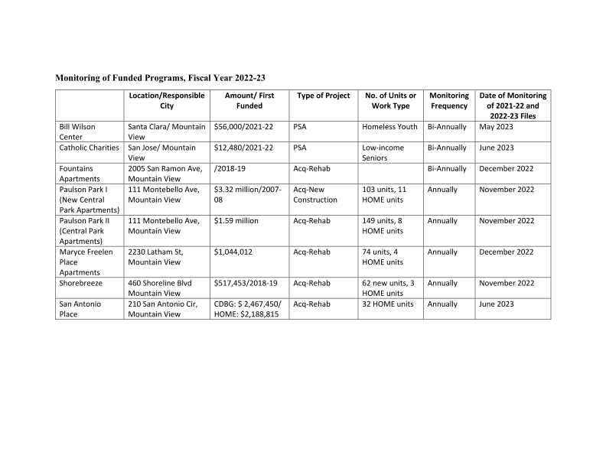

Summary of Public Comments and Notices
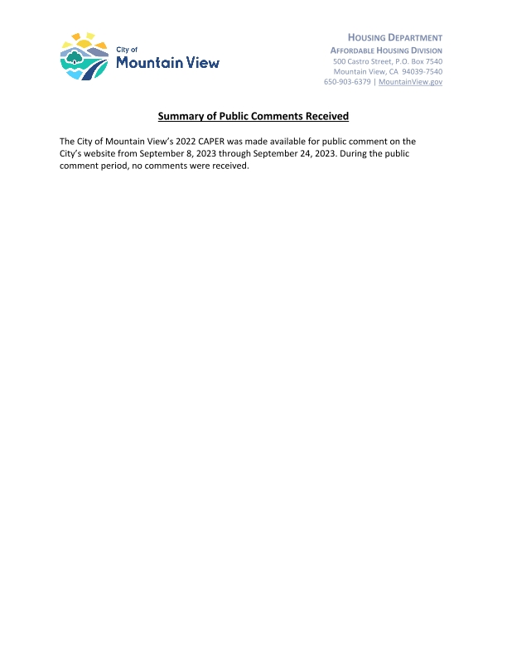
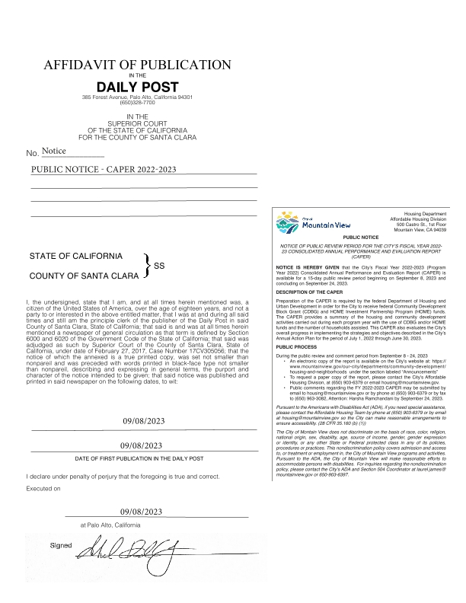
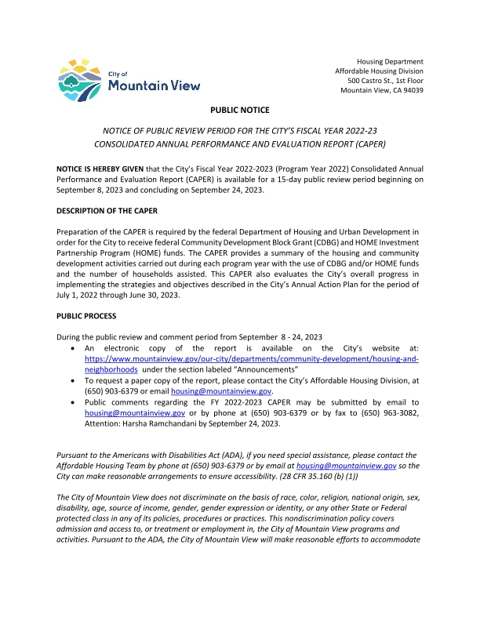
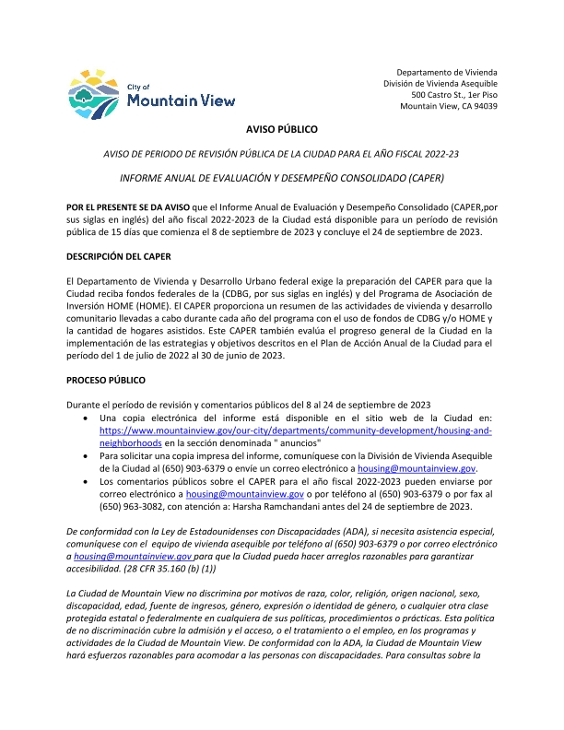
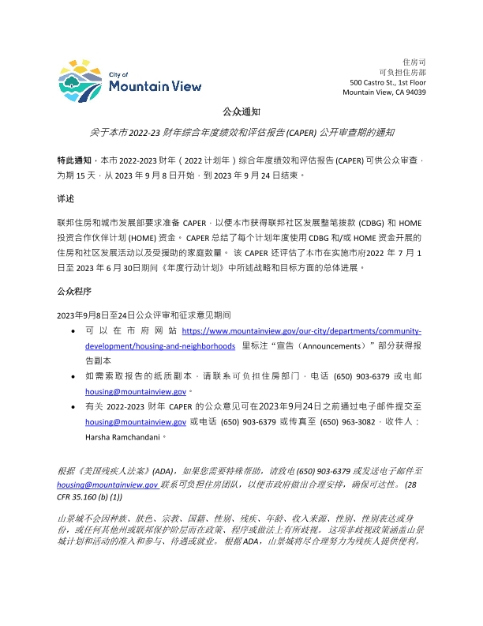
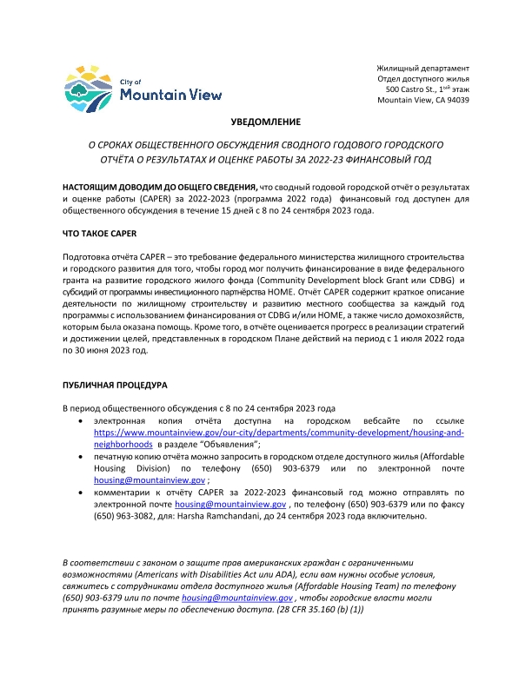
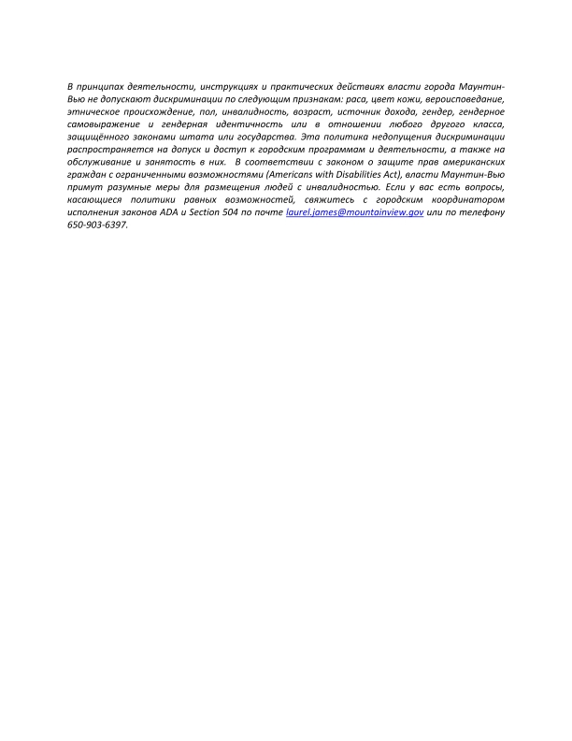

PR-26 Combined
